**DEPLOYMENT**

**About Project:**

Recognizing handwritten digits is a classic problem in computer vision. Variability in handwriting makes it difficult for traditional systems to generalize. Deep learning models like CNNs can automatically extract features and achieve high accuracy. This classification problem has real-world use in postal systems, banking, and digitizing forms.

**INPUT** (png):



**OUTPUT:**

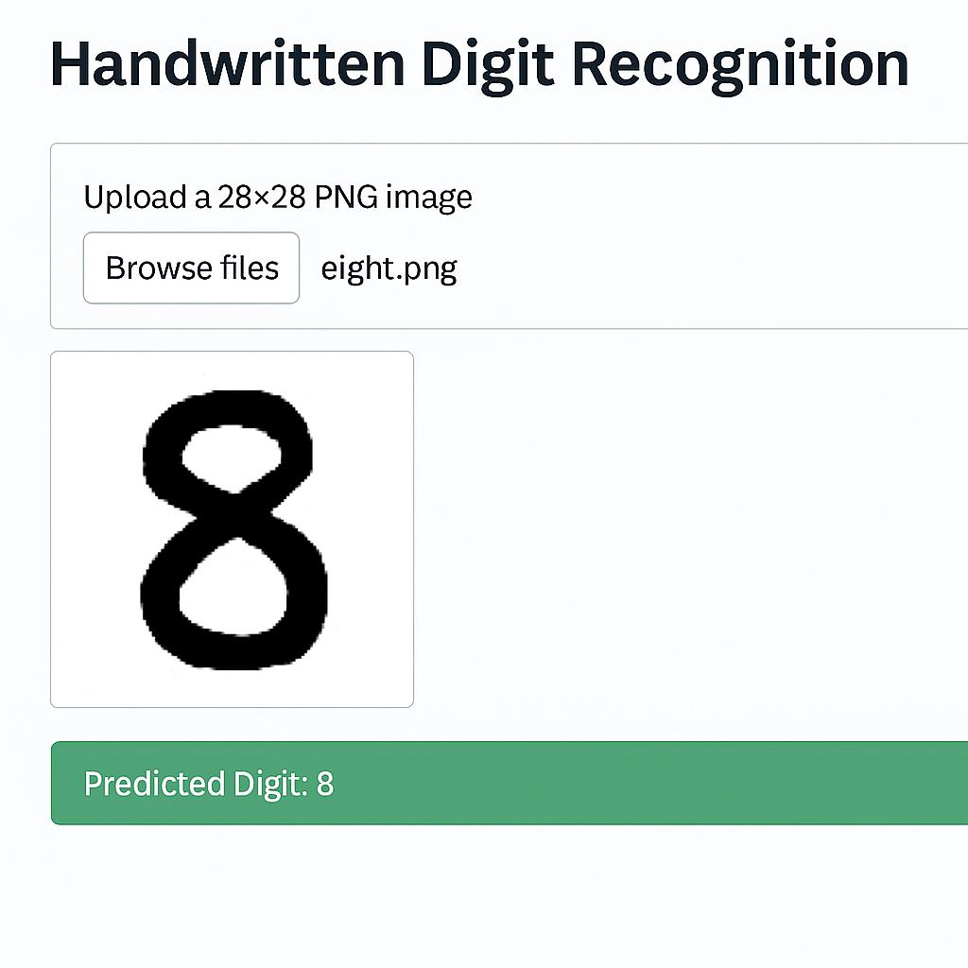

**INPUT:**



**OUTPUT:**

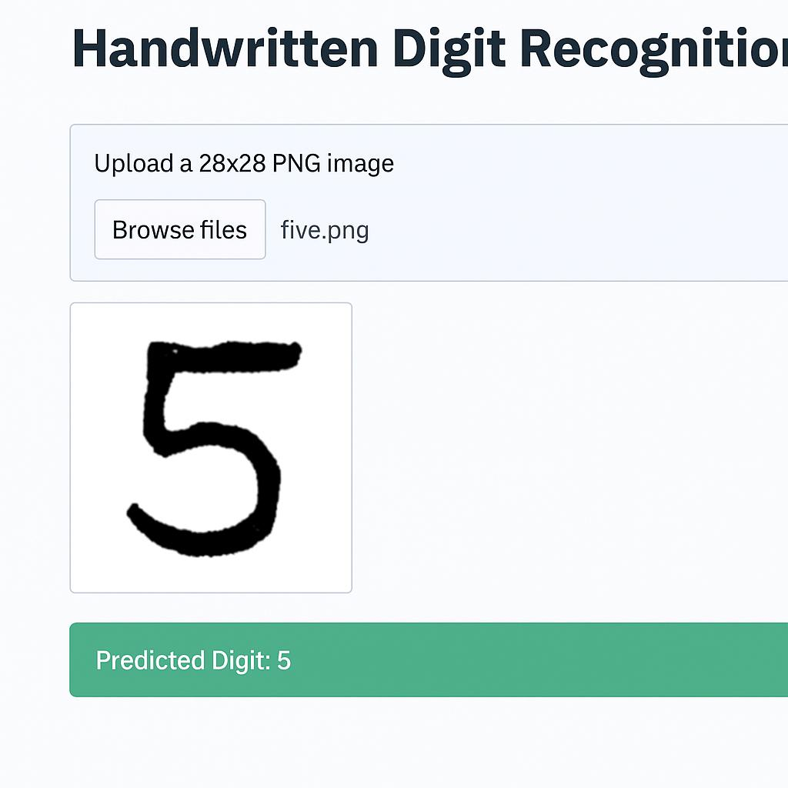

**Accuracy of the model:99.09%**